Computer system -LAB1

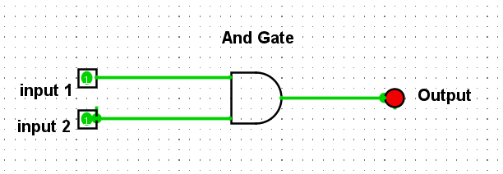

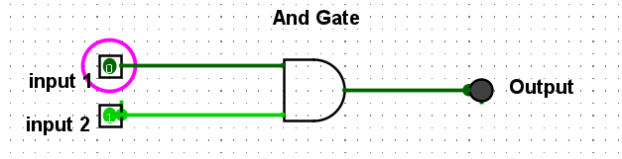

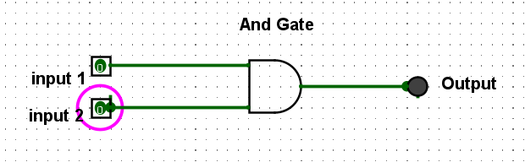

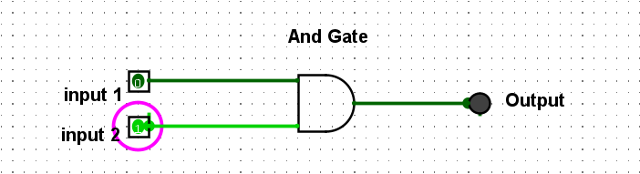
Fig: 1
Pin 1 | Pin 2 | output
0 | 0 | 0
0 | 1 | 0
1 | 0 | 0
1 | 1 | 1

Table: 1

